Nama : Shidqi Aditya Falah

NIM : L202173001

Class : X

PRAKTIKUM 1

**Screenshot Praktikum 1:**

1. Menuju Direktori Kerja

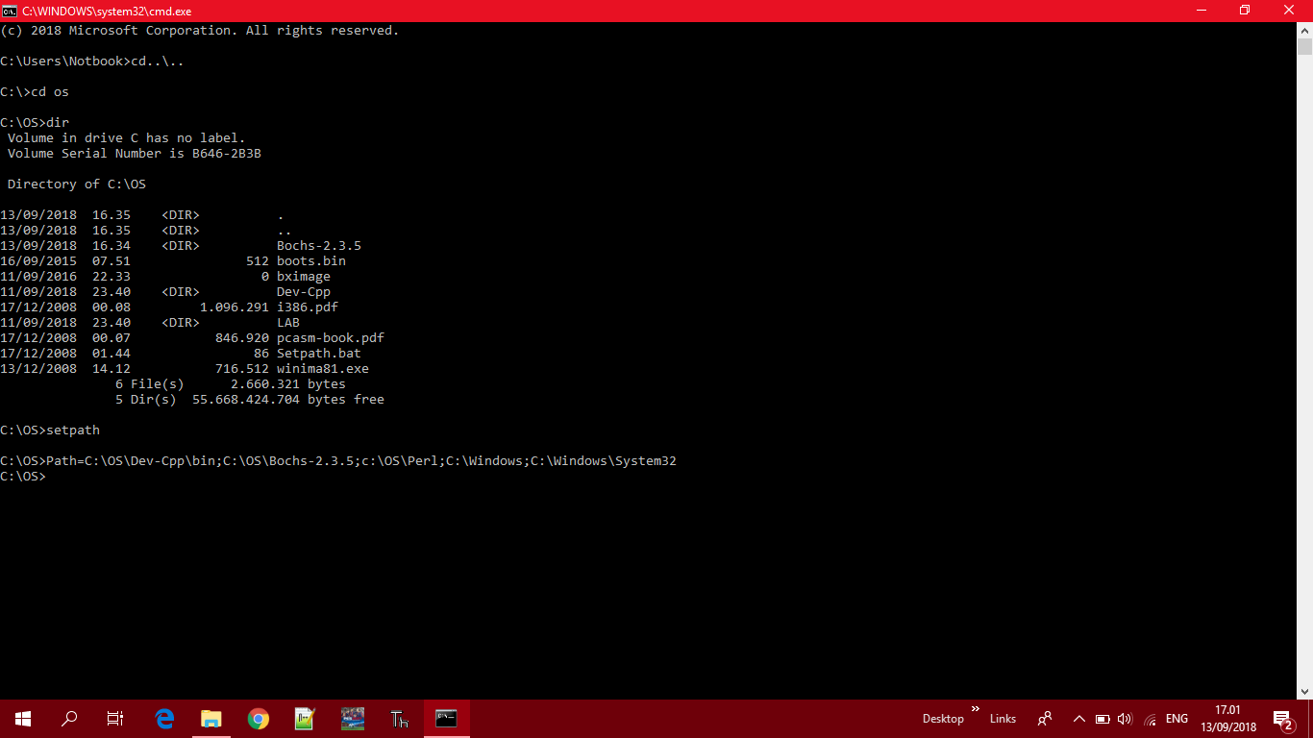

1. Melihat Isi Direktori Kerja

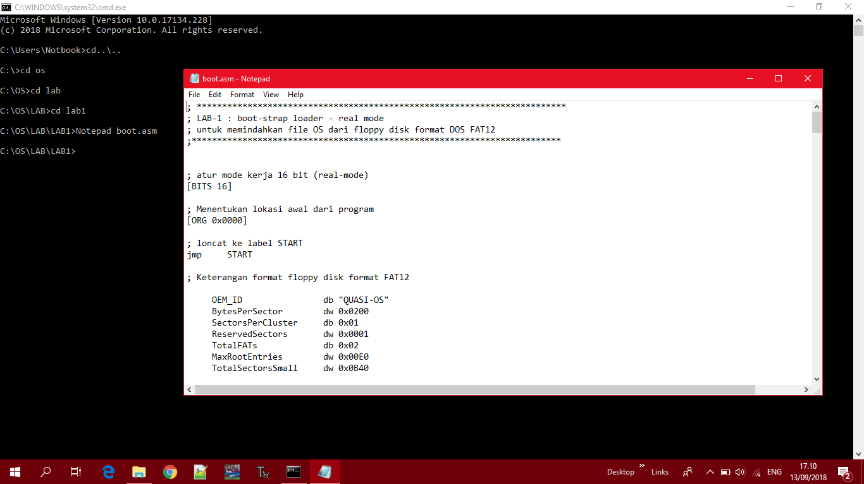

1. Sekilas Tentang Makefile

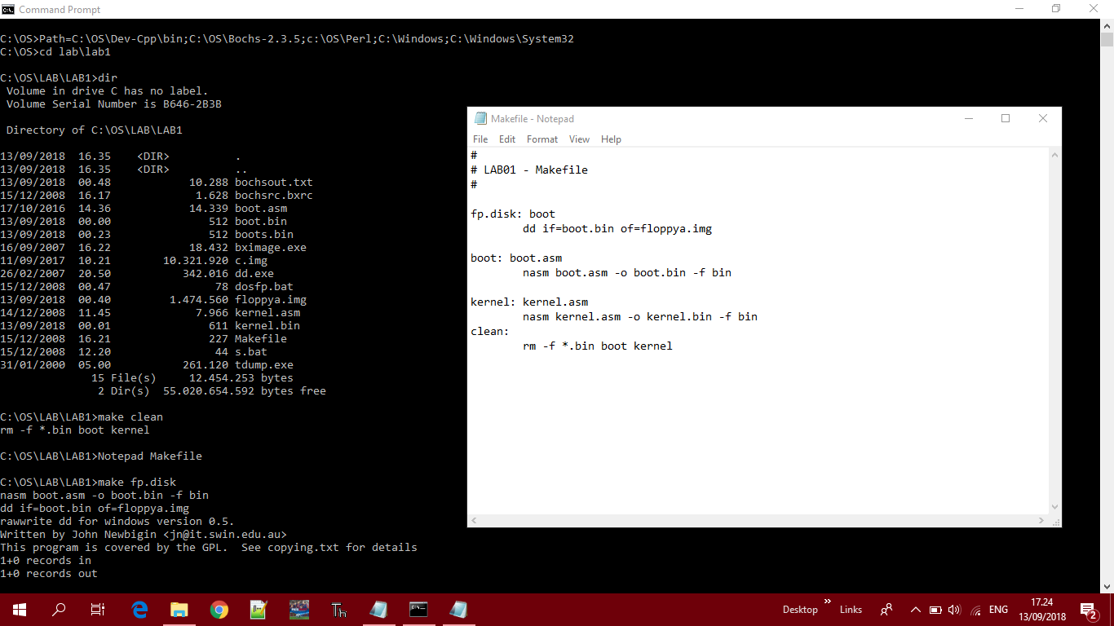

1. Mengenal BOOT DISK

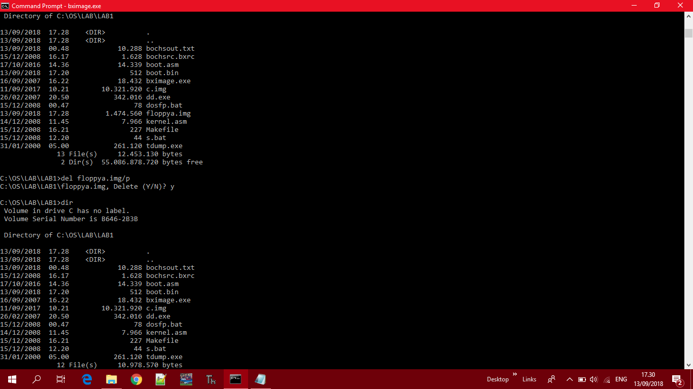

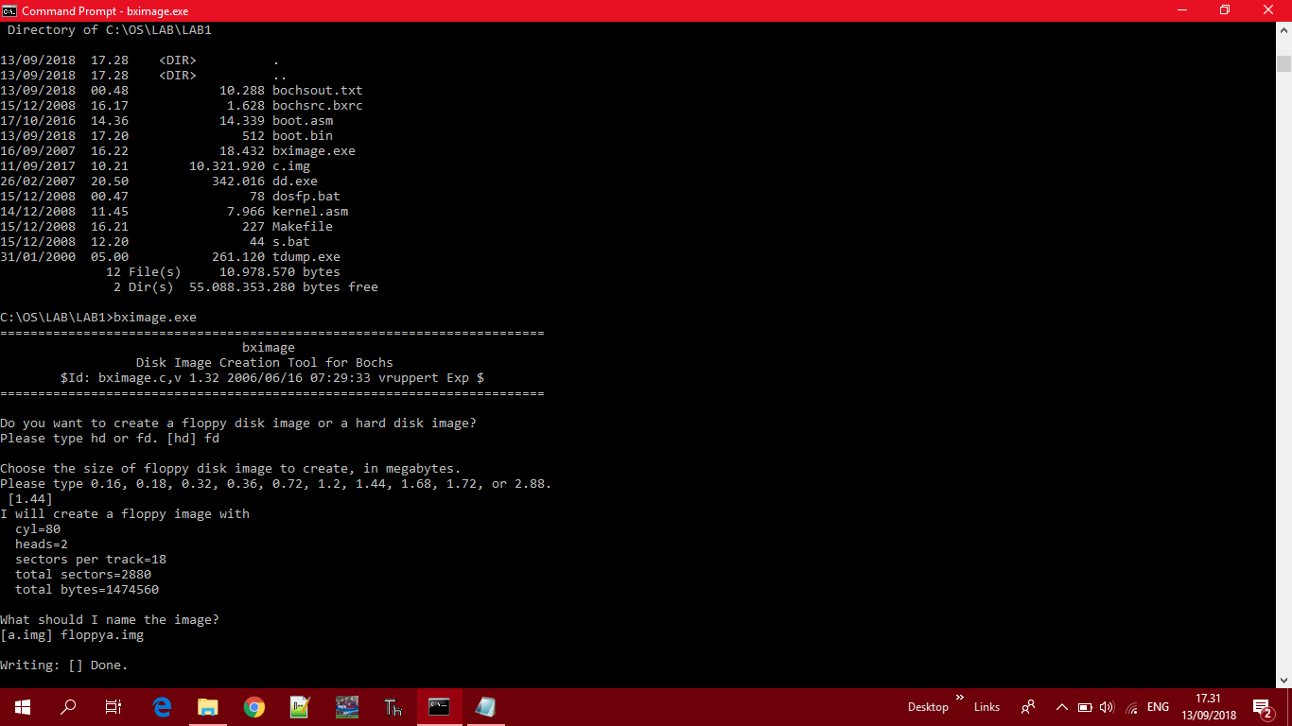

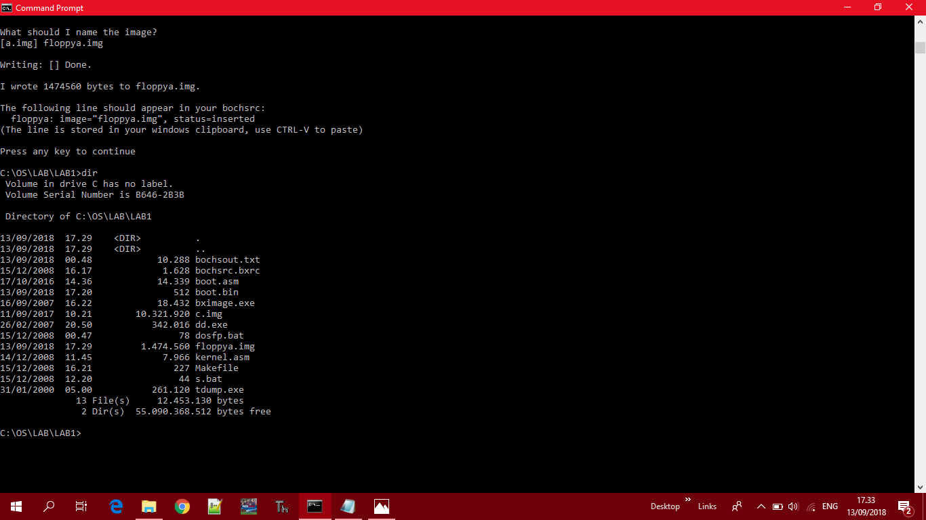

1. Format Floppya Image

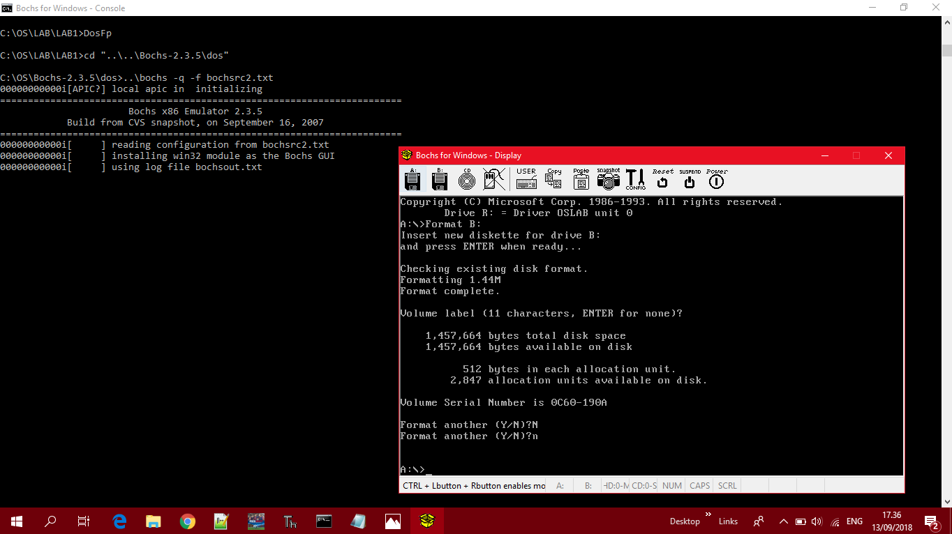

1. Melihat Data dalam Boot Sector

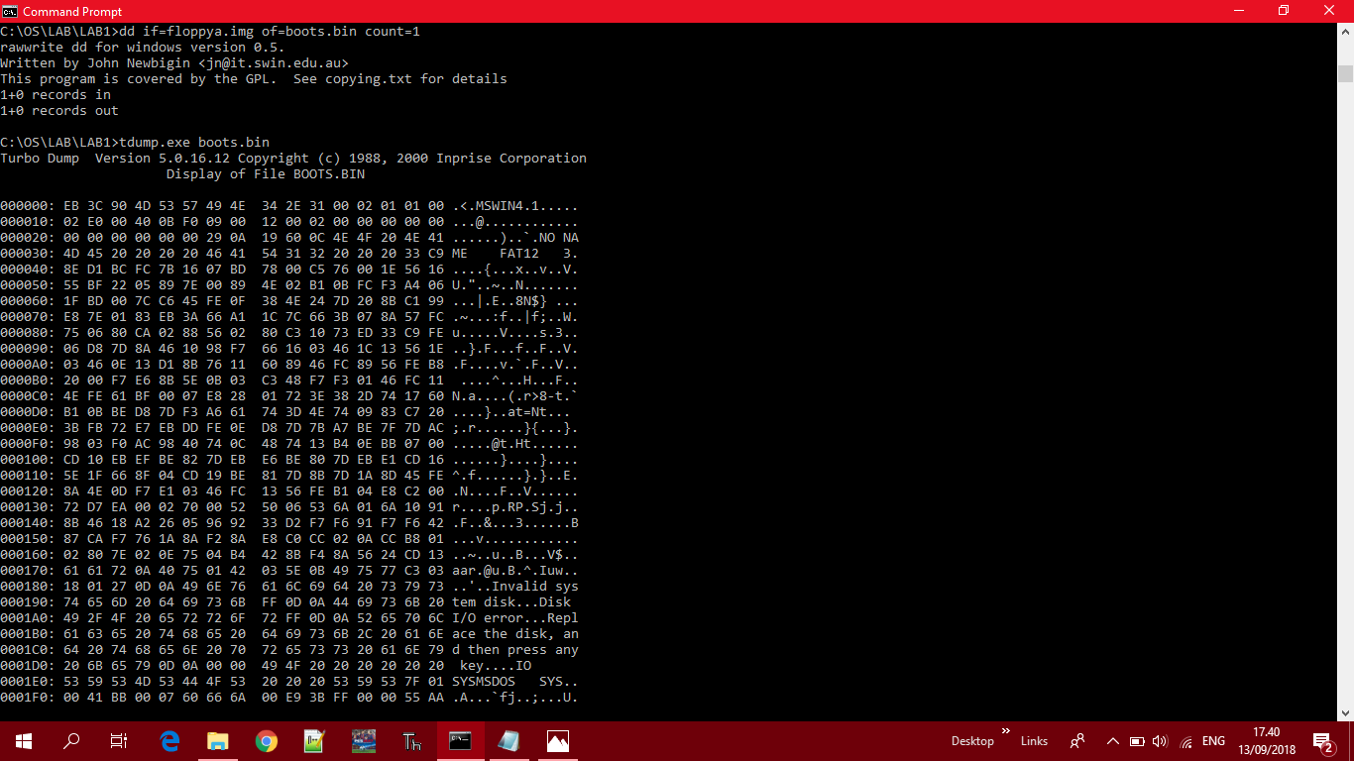

1. “Boot” PC-Simulator dengan File Image “floppy.img”

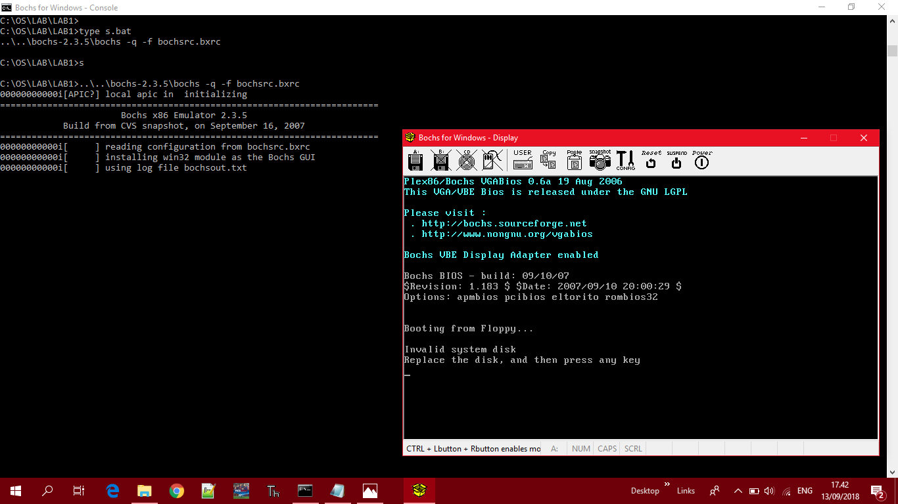

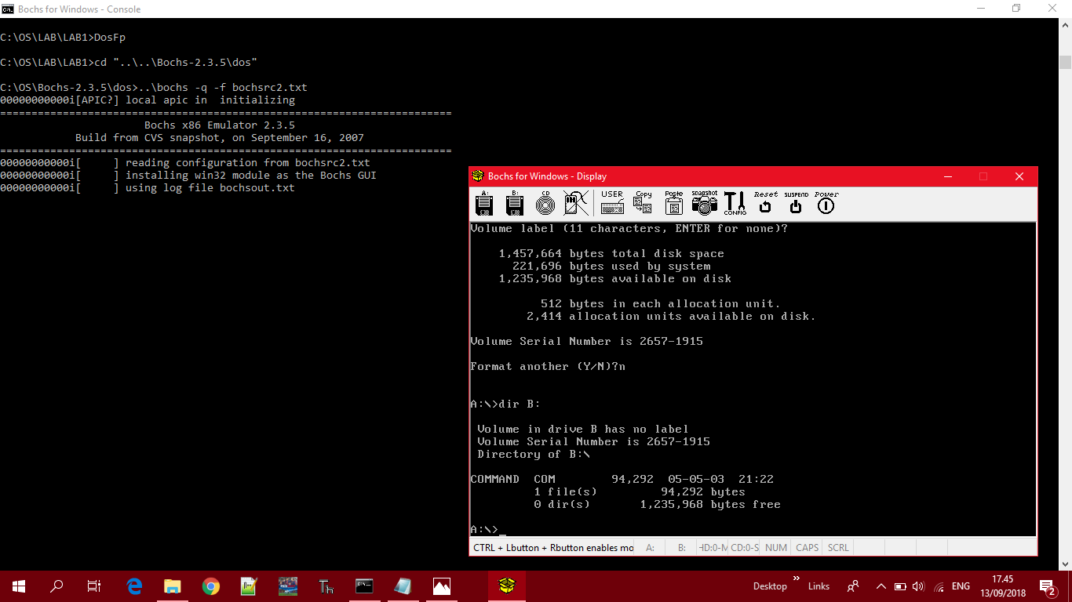

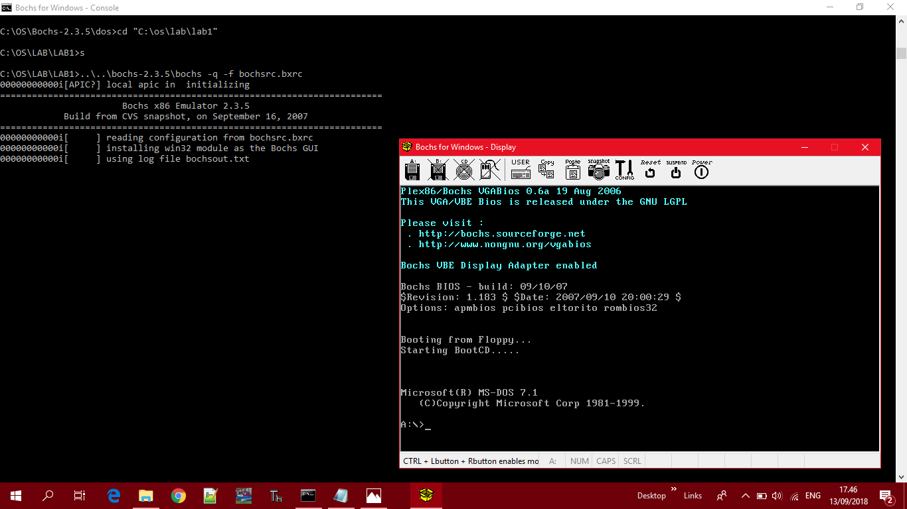

**Tugas:**

Code ASCII

ASCII stands for (American Standard Code for Information Interchange), and the understanding of ASCII itself is an international standard in code letters and symbols such as Hex and Unicode but ASCII is more universal and the function of the ASCII code is used to represent the characters of numbers and letters in the computer, for example we can see the characters 1, 2, 3, A, B, C, and so on.

Table ASCII

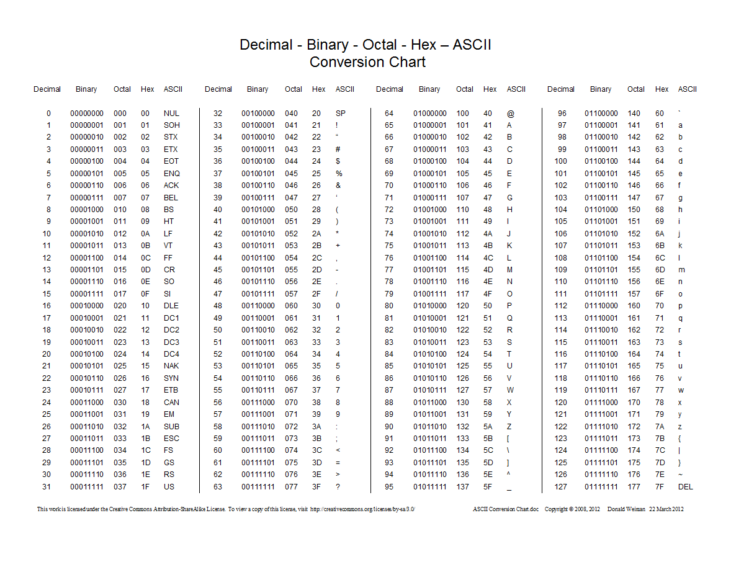

List of Instruction in Assembly Languages

|  |  |
| --- | --- |
| Instruction | Short Description |
| ACALL | Absolute Call |
| ADD | Add |
| ADDC | Add with Carry |
| AJMP | Absolute Jump |
| ANL | AND Logic |
| CJNE | Compare and Jump if Not Equal |
| CLR | Clear |
| CPL | Complement |
| DA | Decimal Adjust |
| DEC | Decrement |
| DIV | Devide |
| DJNZ | Decrement and Jump if Not Zero |
| INC | Increment |
| JB | Jump if Bit Set |
| JBC | Jump if Bit set and Clear Bit |
| JC | Jump if Carry Set |
| JMP | Jump to Address |
| JNB | Jump if Not Bit Set |
| JNC | Jump if Carry Not Set |
| JNZ | Jump if Accumulator Not Zero |
| JZ | Jump if Accumulator Zero |
| LCALL | Long Call |
| LJMP | Long Jump |
| MOV | Move From Memory |
| MOVC | Move From Code Memory |
| MOVX | Move From Extended Memory |
| MUL | Multiply |
| NOP | No Operation |
| ORL | OR Logic |
| POP | Pop Value From Stack |
| PUSH | Push Value Onto Stack |
| RET | Return From Subroutine |
| RETI | Return From Interrupt |
| RL | Rotate Left |
| RLC | Rotate Left through Carry |
| RR | Rotate Right |
| RRC | Rotate Right through Carry |
| SETB | Set Bit |
| SJMP | Short Jump |
| SUBB | Subtract with Borrow |
| SWAP | Swap Nibbles |
| XCH | Exchange Bytes |
| XCHD | Exchange Digits |
| XRL | Exclusive OR Logic |